**Bug Report – Open Cart**

|  |  |  |
| --- | --- | --- |
| **Bug ID** | **Description** | **Severity** |
| BID-01 | 'Thank you for registering' email is not received to the registered email address after registering an account | Minor |
| BID-02 | 'Privacy Policy' Checkbox field in 'Register Account' page is not marked with red colour * symbol | Minor |
| BID-03 | 'Password' and 'Password Confirm' fields in 'Register Account' page are accepting simple passwords | Major |
| BID-04 | Leading and Trailing spaces are accepted by the text fields in the 'Register Account' page | Minor |
| BID-05 | User is getting logged out on clicking Browser back button | Critical |
| BID-06 | User is getting logged in automatically on browsing back immediately after logout | Major |
| BID-07 | Password is visible in the Page Source code of the Password field of 'Login' page | Major |
| BID-08 | User is not automatically getting logged out of the Application after 30 minutes of inactivity | Major |
| BID-09 | User is not getting logged out in one browser, when logged out in another browser | Minor |
| BID-10 | Email address is not getting carry forwarded from the 'Login' page to 'Forgot Your Password' page | Minor |
| BID-11 | Using tab keyboard key is not highlighting the 'Search in subcategories' checkbox field | Minor |
| BID-12 | Negative, Null and Zero values are accepted by the Qty field in Product Display Pages | Minor |
| BID-13 | Warning message informing the User to provide positive quantity is not getting displayed on updating the quantity with negative, zero or blank in the 'Shopping Cart' page | Minor |
| BID-14 | $8 is displayed instead of $5 in the displayed 'Estimate Shipping & Taxes' dialogue | Major |
| BID-15 | User can provide future date for the 'Order Date' field while returning the order | Major |
| BID-16 | Page text is not displayed in the 'About Us', 'Delivery Information', 'Privacy Policy' and 'Terms & Conditions' page | Minor |
| BID-17 | Normal User who has not registered for the Affiliate account is able to login from 'Affiliate Login' section | Minor |
| BID-18 | A blank 'Contact Us' page is displayed on submitting the form in 'Contact Us' page | Minor |

|  |  |
| --- | --- |
| **Bug ID** | BID-01 |
| **Summary** | 'Thank you for registering' email is not received to the registered email address after registering an account |
| **Severity** | Minor |

**Step To Reproduce:**

1. Open the Application URL
2. Click on 'My Account' drop menu
3. Select 'Register' option
4. Enter the new User valid details into the 'Register Account' page
5. Select the 'Privacy Policy' checkbox option
6. Click on 'Continue' button

**Expected Result:**

User Account should be created and an email with the subject 'Thank you for registering' should be received by the registered email address.

**Actual Result:**

User Account is getting created, but the email with subject 'Thank you for registering' is not received to the registered email address.

**Screenshot**

Not Applicable

|  |  |
| --- | --- |
| **Bug ID** | BID-02 |
| **Summary** | 'Privacy Policy' Checkbox field in 'Register Account' page is not marked with red colour * symbol |
| **Severity** | Minor |

**Step To Reproduce:**

1. Open the Application URL in any browser

2. Click on 'My Account' Drop menu

3. Select 'Register' option

4. Check the 'Privacy Policy' checkbox field in the displayed 'Register Account' page.

**Expected Result:**

'Privacy Policy' check box field should be marked with red colour * symbol

**Actual Result:**

'Privacy Policy' check box field is mandatory but not marked with red colour * symbol.

**Screenshot**

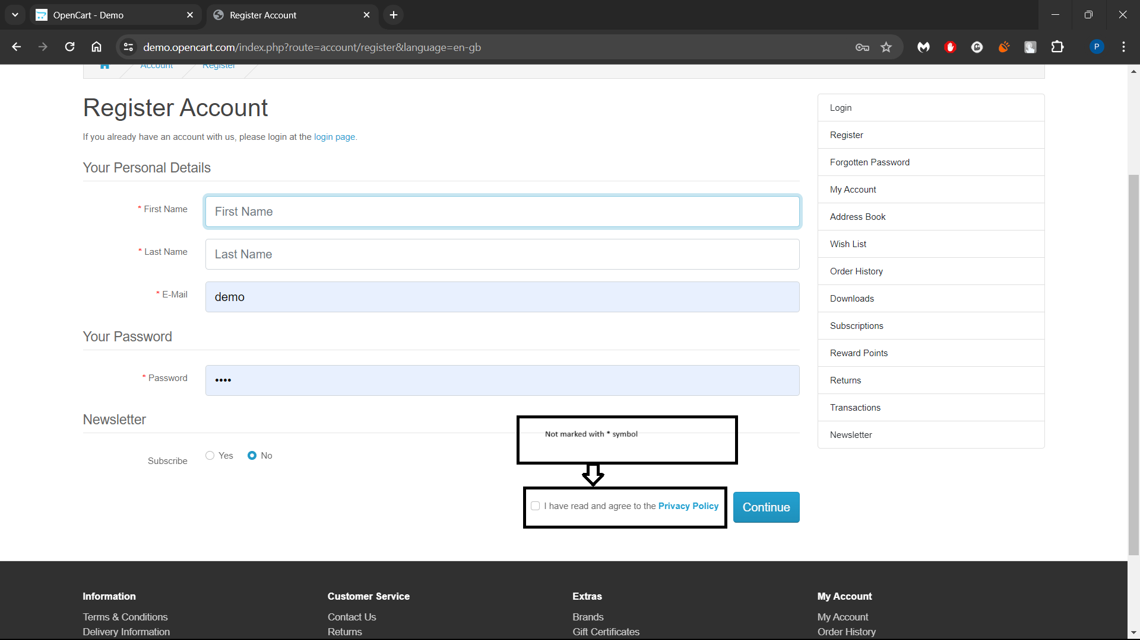

|  |  |
| --- | --- |
| **Bug ID** | BID-03 |
| **Summary** | 'Password' and 'Password Confirm' fields in 'Register Account' page are accepting simple passwords |
| **Severity** | Major |

**Step To Reproduce:**

1. Open the Application URL in any browser
2. Click on 'My Account' drop menu
3. Select 'Register' option
4. Enter details into all the mandatory fields
5. Enter simple password say 'abcd' into the 'Password' and 'Password Confirm' fields
6. Select 'Privacy Policy' checkbox field
7. Click on 'Continue' button

**Expected Result:**

Warning message informing the User to enter a password matching the complexity standards should be displayed

**Actual Result:**

Simple password got accepted and there is no warning message regarding the complexity standards of the Password.

**Screenshot**

Not Applicable

|  |  |
| --- | --- |
| **Bug ID** | BID-04 |
| **Summary** | Leading and Trailing spaces are accepted by the text fields in the 'Register Account' page |
| **Severity** | Minor |

**Step To Reproduce:**

1. Open the Application URL in any browser
2. Click on 'My Account' drop menu
3. Select 'Register' option
4. Enter leading and trailing spaces to the text fields in the 'Register Account' page
5. Select 'Privacy Policy' checkbox field
6. Click on 'Continue' button

**Expected Result:**

Leading and Trailing spaces should not be accepted by the text fields in the 'Register Account' page

**Actual Result:**

Leading and Trailing spaces are accepted by the text fields in the 'Register Account' page and account is getting created

**Screenshot**

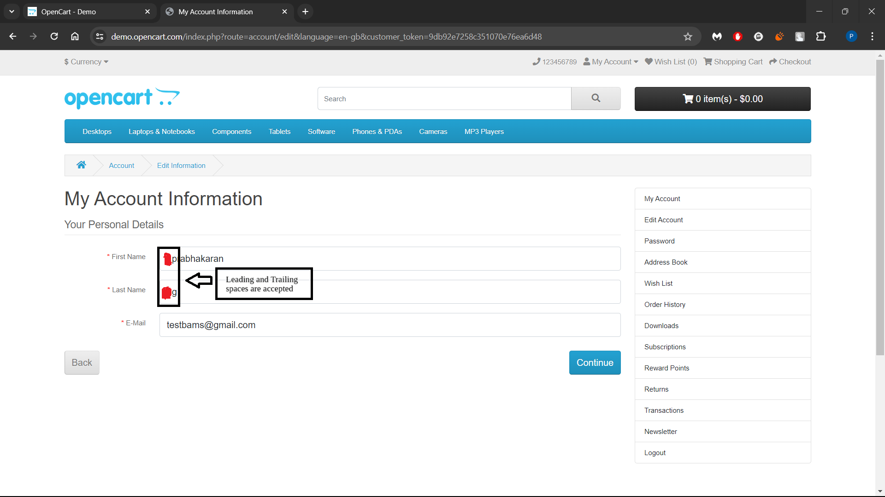

|  |  |
| --- | --- |
| **Bug ID** | BID-05 |
| **Summary** | User is getting logged out on clicking Browser back button |
| **Severity** | Critical |

**Step To Reproduce:**

1. Open Application URL in any browser
2. Click on 'My Account' drop menu
3. Select 'Login' option
4. Enter valid email address into 'E-Mail Address' field and valid password into 'Password' field
5. Click on 'Login' button
6. Click on browser back button two times

**Expected Result:**

User should not get logged out

**Actual Result:**

User is getting logged out

**Screenshot**

Not Applicable

|  |  |
| --- | --- |
| **Bug ID** | BID-06 |
| **Summary** | User is getting logged in automatically on browsing back immediately after logout |
| **Severity** | Major |

**Step To Reproduce:**

1. Login to the Application
2. Click on 'My Account' drop menu
3. Select 'Logout' option
4. Click on browser back button

**Expected Result:**

User should not get logged in automatically

**Actual Result:**

User is getting logged in automatically

**Screenshot**

Not Applicable

|  |  |
| --- | --- |
| **Bug ID** | BID-07 |
| **Summary** | Password is visible in the Page Source code of the Password field of 'Login' page |
| **Severity** | Major |

**Step To Reproduce:**

1. Open Application URL in any browser
2. Click on 'My Account' drop menu
3. Select 'Login' option
4. Enter password into the 'Password' field on the 'Login' page
5. Click on 'Login' button
6. Inspect the 'Password' text field

**Expected Result:**

Password should not be visible in the Page Source code

**Actual Result:**

Password is getting displayed in the Page Source code as shown in the attached screenshot

**Screenshot**

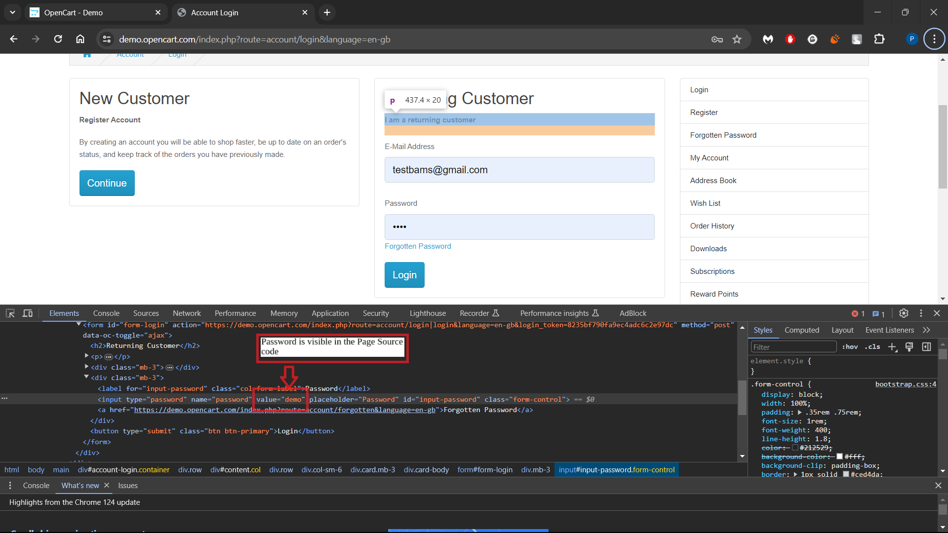

|  |  |
| --- | --- |
| **Bug ID** | BID-08 |
| **Summary** | User is not automatically getting logged out of the Application after 30 minutes of inactivity |
| **Severity** | Major |

**Step To Reproduce:**

1. Login to the Application with valid credentials
2. Don't perform any action for next 30 minutes
3. Try to perform any action after the above 30 minutes like Search a product etc.

**Expected Result:**

User should get automatically logged out

**Actual Result:**

User is not getting logged out

**Screenshot**

Not Applicable

|  |  |
| --- | --- |
| **Bug ID** | BID-09 |
| **Summary** | User is not getting logged out in one browser, when logged out in another browser |
| **Severity** | Minor |

**Step To Reproduce:**

1. Login to the Application with same credentials in Chrome and Firefox Browser
2. Logout in Chrome browser
3. Check performing any action in Firefox browser

**Expected Result:**

User should also get logged out in Firefox browser

**Actual Result:**

User is not getting logged out automatically in Firefox browser

**Screenshot**

Not Applicable

|  |  |
| --- | --- |
| **Bug ID** | BID-10 |
| **Summary** | Email address is not getting carry forwarded from the 'Login' page to 'Forgot Your Password' page |
| **Severity** | Minor |

**Step To Reproduce:**

1. Open Application URL
2. Click on 'My Account' drop menu
3. Select 'Login' option
4. Enter email address into the 'E-Mail Address' text field
5. Click on 'Forgotten Password' link

**Expected Result:**

Email address given in Login page should get carry forwarded to 'Forgot Your Password' page

**Actual Result:**

Email address given in Login page is not getting carry forwarded to 'Forgot Your Password' page

**Screenshot**

Not Applicable

|  |  |
| --- | --- |
| **Bug ID** | BID-11 |
| **Summary** | Using tab keyboard key is not highlighting the 'Search in subcategories' checkbox field |
| **Severity** | Minor |

**Step To Reproduce:**

1. Open Application URL
2. Click on 'Search' icon without entering any product name
3. In the displayed 'Search' page, continuously press 'Tab' keyboard key

**Expected Result:**

All the options on the 'Search' page should get highlighted/focused.

**Actual Result:**

'Search in subcategories' checkbox field is not highlighted or focused.

**Screenshot**

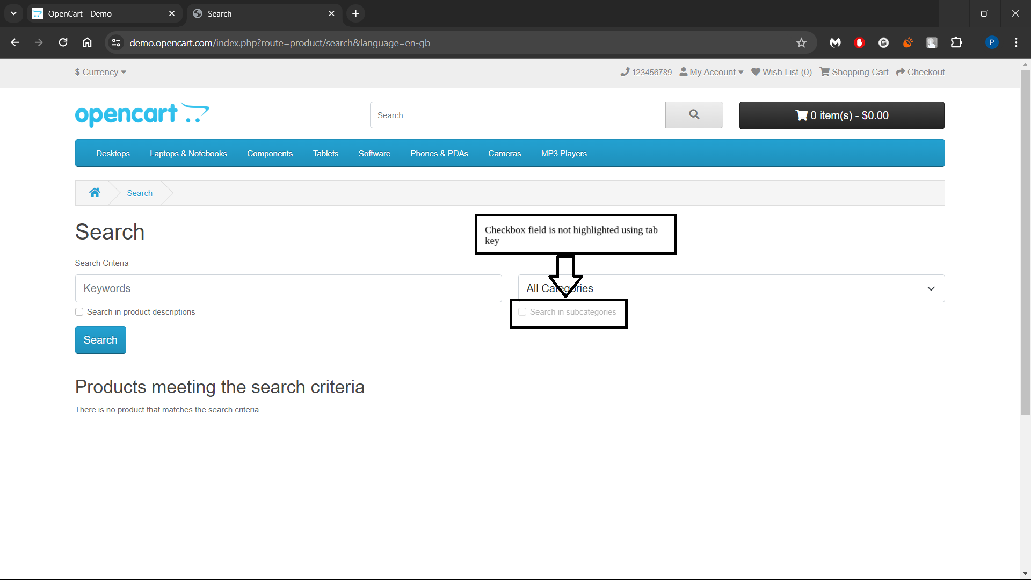

|  |  |
| --- | --- |
| **Bug ID** | BID-12 |
| **Summary** | Negative, Null and Zero values are accepted by the Qty field in Product Display Pages |
| **Severity** | Minor |

**Step To Reproduce:**

1. Open Application URL
2. Enter any Product Name say 'iMac' into the Search box field
3. Click on the button having Search icon
4. Click the Product displayed in the Search results
5. Change the quantity to Negative or Blank or Zero in the Qty field of Product Display Page
6. Click on 'Add to Cart' button

**Expected Result:**

Warning message informing the User to enter a positive quantity into the Qty field should be displayed

**Actual Result:**

Success message with text - Success: You have added Product to your shopping cart! is getting displayed

**Screenshot**

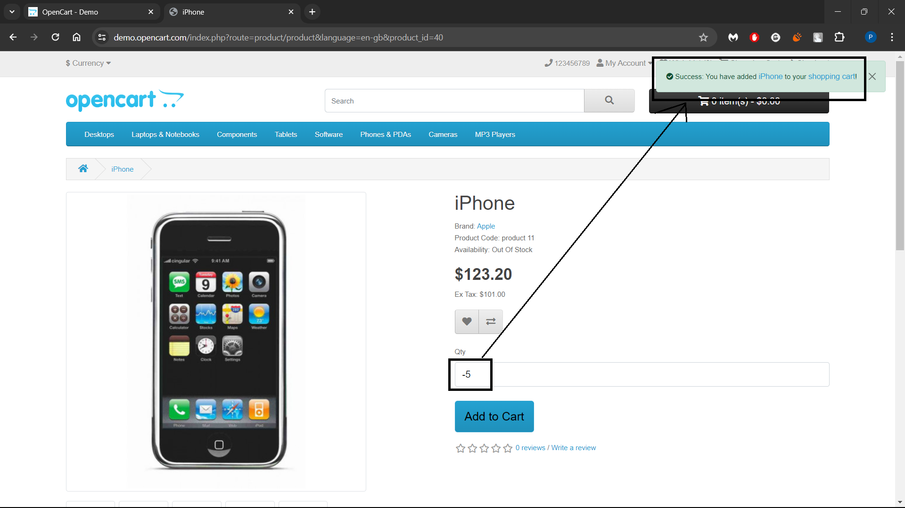

|  |  |
| --- | --- |
| **Bug ID** | BID-13 |
| **Summary** | Warning message informing the User to provide positive quantity is not getting displayed on updating the quantity with negative, zero or blank in the 'Shopping Cart' page |
| **Severity** | Minor |

**Step To Reproduce:**

1. Open Application URL
2. Enter any Product say 'iMac' in the Search box field
3. Click on 'Search' icon button
4. Click on 'Add to Cart' button on the product displayed in the Search Results page
5. Click on 'Shopping Cart' header option
6. Enter -5 into the Quantity field
7. Click on 'Update' icon option

**Expected Result:**

Warning message informing the User to provide the positive quantity should be displayed

**Actual Result:**

No warning message is getting displayed, instead 'Your shopping cart is empty!' is getting displayed

**Screenshot**

Not Applicable

|  |  |
| --- | --- |
| **Bug ID** | BID-14 |
| **Summary** | $8 is displayed instead of $5 in the displayed 'Estimate Shipping & Taxes' dialogue |
| **Severity** | Major |

**Step To Reproduce:**

1. Open any Application URL
2. Navigate to Shopping Cart page after adding a Product to Cart
3. Click on 'Estimate Shipping & Taxes' dialogue
4. Enter Country say 'United States' into the 'Country' text field
5. Enter Region/State say 'California' into the 'Region/State' text field
6. Click on 'Get Quotes' button

**Expected Result:**

$5 should be displayed in the 'Estimate Shipping & Taxes' dialogue

**Actual Result:**

For the first time after opening the browser and following the steps to reproduce, $8 is getting displayed in the 'Estimate Shipping & Taxes' dialogue

**Screenshot**

Not Applicable

|  |  |
| --- | --- |
| **Bug ID** | BID-15 |
| **Summary** | User can provide future date for the 'Order Date' field while returning the order |
| **Severity** | Major |

**Step To Reproduce:**

1. Login to the Account having few orders placed
2. Click on 'Order History' Right column option
3. Click on 'View' icon option of any order displayed in the table of 'Order History' page
4. Enter any future date into the 'Order Date' field in the displayed 'Product Returns' page
5. Provide/Select all the mandatory fields and click on 'Submit' button

**Expected Result:**

Warning message informing the User to provide a valid date should be displayed

**Actual Result:**

Future Date provided in the 'Order Date' field is accepted and return is placed

**Screenshot**

Not Applicable

|  |  |
| --- | --- |
| **Bug ID** | BID-16 |
| **Summary** | Page text is not displayed in the 'About Us', 'Delivery Information', 'Privacy Policy' and 'Terms & Conditions' page |
| **Severity** | Minor |

**Step To Reproduce:**

1. Open Application URL
2. Click on 'About Us' footer option or other footer options like 'Delivery Information', 'Privacy Policy’ and 'Terms & Conditions' page

**Expected Result:**

Proper page text should be displayed in the pages

**Actual Result:**

No page text is getting displayed in the page as shown in the attached screenshot

**Screenshot**

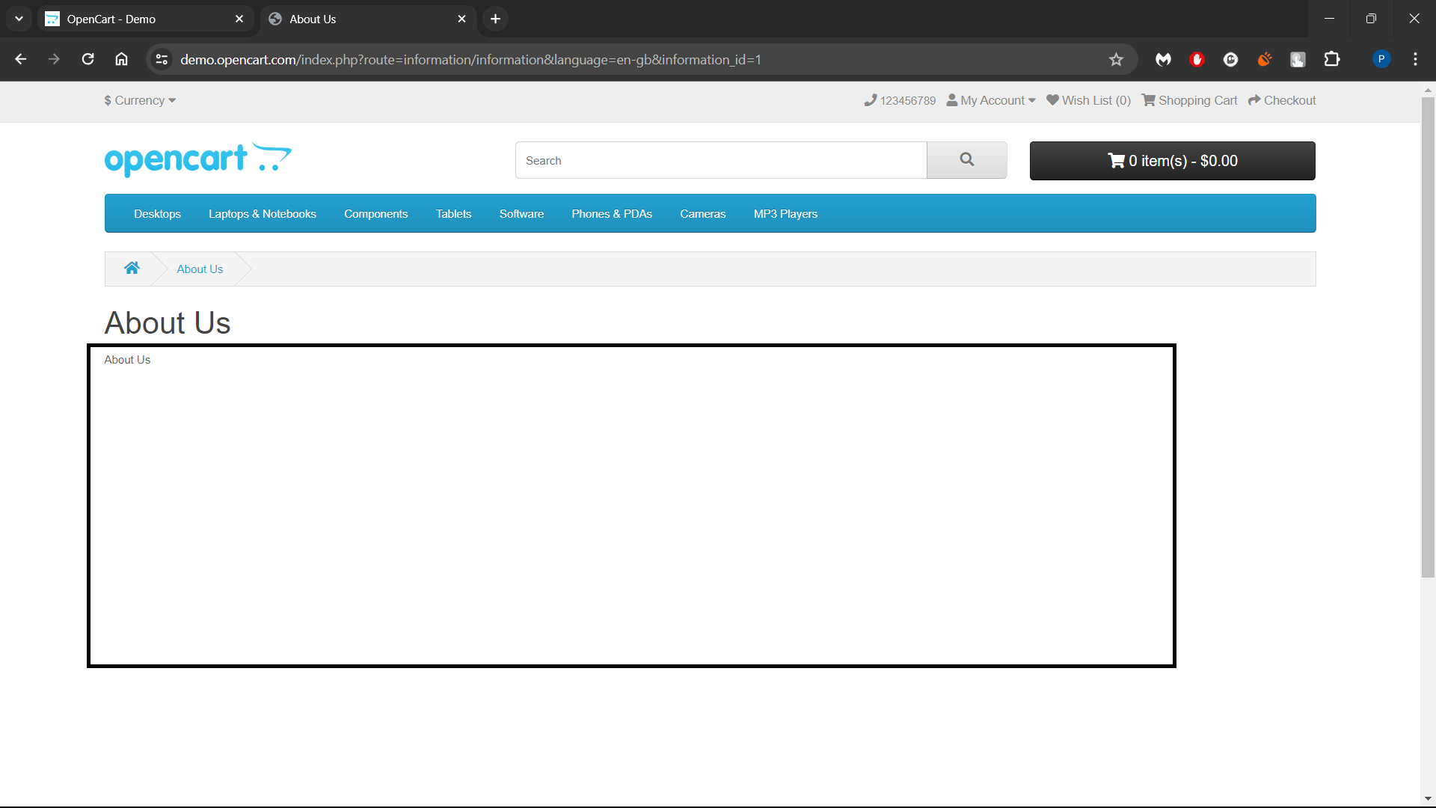

|  |  |
| --- | --- |
| **Bug ID** | BID-17 |
| **Summary** | Normal User who has not registered for the Affiliate account is able to login from 'Affiliate Login' section |
| **Severity** | Minor |

**Step To Reproduce:**

1. Open Application URL
2. Click on 'Affiliate' footer link
3. Login from the 'Affiliate Program' page by providing credentials of the normal User who has not registered for an Affiliate account from the 'Affiliate Login' section
4. Click on 'Login' button

**Expected Result:**

User doesn't have any affiliate account warning message should be displayed

**Actual Result:**

Normal User not registered for affiliate account is able to login as shown in the attached screenshot

**Screenshot**

Not Applicable

|  |  |
| --- | --- |
| **Bug ID** | BID-18 |
| **Summary** | A blank 'Contact Us' page is displayed on submitting the form in 'Contact Us' page |
| **Severity** | Minor |

**Step To Reproduce:**

1. Open Application URL
2. Click on 'Contact Us' footer option
3. Enter the details into 'Your Name', 'E-Mail Address' and 'Enquiry' fields in the 'Contact Us' page
4. Click on 'Submit' button

**Expected Result:**

Success Message with text - 'Your Enquiry has been Submitted!' should be displayed in the 'Contact Us' page.

**Actual Result:**

A blank 'Contact Us' page is getting displayed as shown in the attached screenshot

**Screenshot**

